
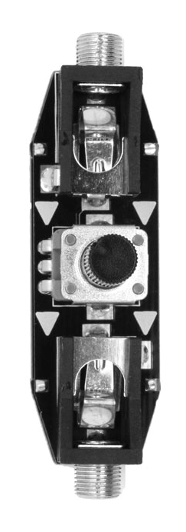

LjunggrenAudio RYO Airtenuator
a floating passive attenuator

Quickstart – what is the Airtenuator and how do I get going?

The RYO Airtenuator is a floating passive attenuator you connect between two modules in your rack via patch cables, acting as a volume/modulation depth control between the source and destination.

Installation

To begin installation, please make sure that:
- you have a standard pinout eurorack bus board
- you have +12V and -12V power rails on that bus board [no +5V supply is required]
- the power rails are not overloaded

!!!Before installing this module disconnect the power from your system!!!

- Double check the polarity of the ribbon cable - The red stripe should be aligned with the -12V rail, on both the module and on the bus board

[we use shrouded headers but it's still possible a cable has been assembled with the stripe on the wrong side of the shroud so always double check!].

Also make sure when using busboards without shrouded headers that the pins aren't transposed a row vertically or horizontally – all pins should insert into holes on the cable.

Although we use both PTC fuses and schottky diodes to provide reverse polarity and excess current protection, we do not take any responsibility for damages caused by wrong power supply connection!

After you have connected everything, double checked it and ensured your case is closed such that no power lines can be touched by your hand or any stray cables drop into holes, turn on your system and test the module

Instead of being built into a module that sits mounted in your modular case these attenuators "float" in the air held up firmly by the two cables connected to it, thanks to the firm fit it is possible to make precise adjustments one-handed and they can also easily be twisted into an angle that works best for the specific task and placement in your patch.

One handed operation is tested on patch cables from Ad-Infinitum, Erthenvar (standard and IV) and TipTop Stackcables.

Can handle any signal between -10V and +10V (the Doepfer A-100 eurorack standard maximum signal range)

Dimensions
Length: 58mm
Width: 16mm
Depth: floating (cables attached)

Weight: ???g

Current consumption
+12V rail 0.2mA
-12V rail no -12V supply required
+5V rail no +5V supply required

@ 10V signal +/-20% from the output jack

Basic specifications
total frequency controllable range dc to 50+kHz
max input/output audio signal 20Vpp
CV input range -10V to +10V

Max gain n/a

Nominal impedances
Audio signal input: 50k ohms +/-20%
Audio Signal output: (variable impedance if used backwards)
CV input: n/a

Patch ideas:

Although uses of attenuators in patch examples and ideas are found readily online and in some books there are some other less obvious ways to use the airtenuator in patches in your modular rig:

below i've included some inspiring words to show patches that might be tried and expanded upon; and, as ever, experiment – RYO modules are designed with all necessary protection and fail-safes so you can just start plugging in patch cables and see what happens!

Attenuate signals you wouldn't think immediately to attenuate;
many patches that have CV or audio rate modulation in the CV-path can be attenuated to vary the resulting range of tonal outputs - try something different such as attenuating an FM or AM modulator wave so that the resulting sound output from a carrier VCO/VCF/VCA is wildly different.

As a live performance tool;
rather than having an attenuator knob on a module or the in chain mixer/attenuator/whatever buried in a nest of cable spaghetti, pop an airtenuator into the desired signal path and adjust the angle so its convenient to adjust without having to fight through a tangle.

Modulate decay times and filters organically;
Your lovely acid or donk bass is great with a little modulation, but modulating the amount of modulation with your hand gives you a more organic sound - delightfully off-beat yet ear-tinglingly satisfying.

Create a simple mixer;
Multiple parallel Airtenuators can be connected at the outputs with a stackable cable or mult to create a crude mixer - great for combining modulation sources or audio, or both.

Organic fades right at your fingertips;
Sometimes you want to fade voices in and out, but your mixer is covered in cables. Airtenuators can be used to organically fade in and out, or quickly start and stop, an audio or CV source, away from other cables.

Add attenuators to modules without;
So many modules today save space by removing attenuators, requiring you to get a separate attenuator module, negating the point of removing them from the original module. Airtenuators allow you to add modulation amount controls to anything, quickly and easily - even just to fine-tune an existing attenuator!

Quickly get line-level signals from your modular;
Output modules take up space and power. Airtenuators don't! Simply patch out of your module into a set of Airtenuators, then to your interface or console for clear signals without clipping.

